# PRISONERS SYSTEM

**Subject: Database**

**DR: Huda Amin**

**TA: Sara Shehata**

**Team members:**

-Ahmed Mohamed

-Ahmed Abdelaziz

-Ann Ahdy

-Michael Raouf

-Abdelrahman Abdallah

**Cleary ERD in terms of relations** 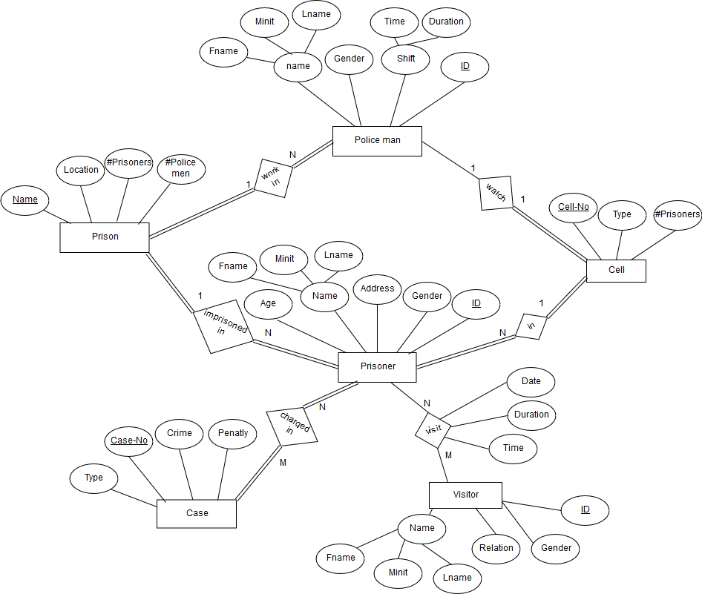

**ERD**

**-At first just create sequences :**



**-then create Prisoners table:**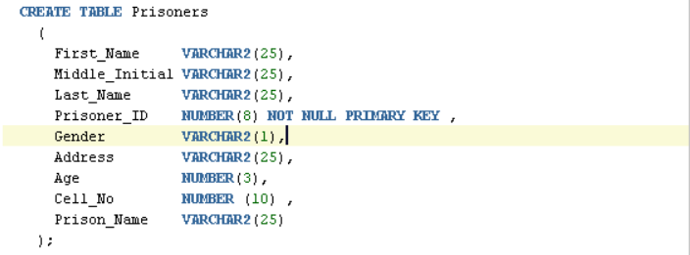

**-then create Prisons table:**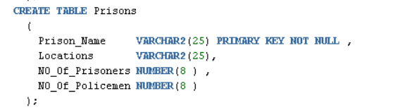

**-Create Cases table:**

**-Create Charged_in Table:**

